**PRACTICAL ACTIVITY 5**

**QUESTION 1 & 2**

**The organization comprise of headquarter and 2 sales locations. In each locations, there is 3 departments, sales mechanical and management. In the headquarter there are 3 departments administrative accounting and hr. In each department I created some users**

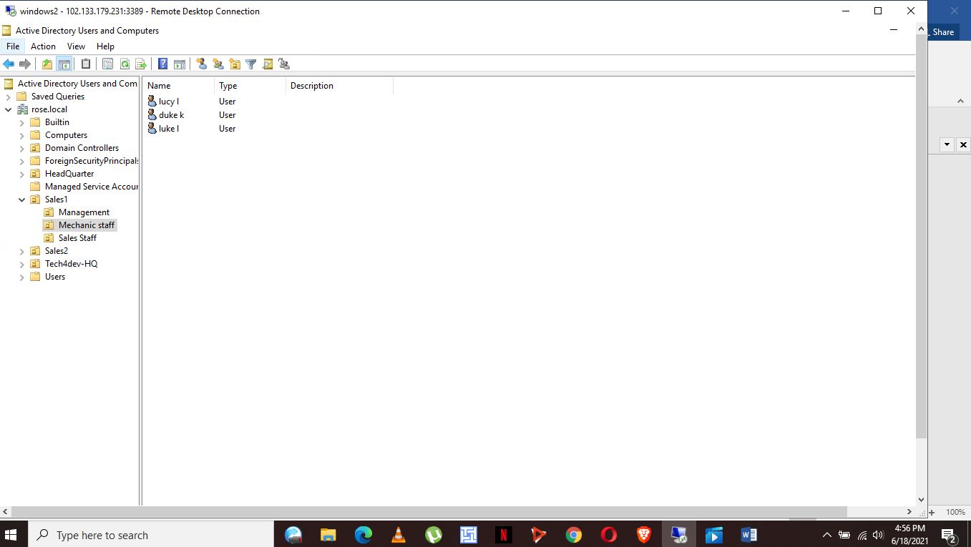

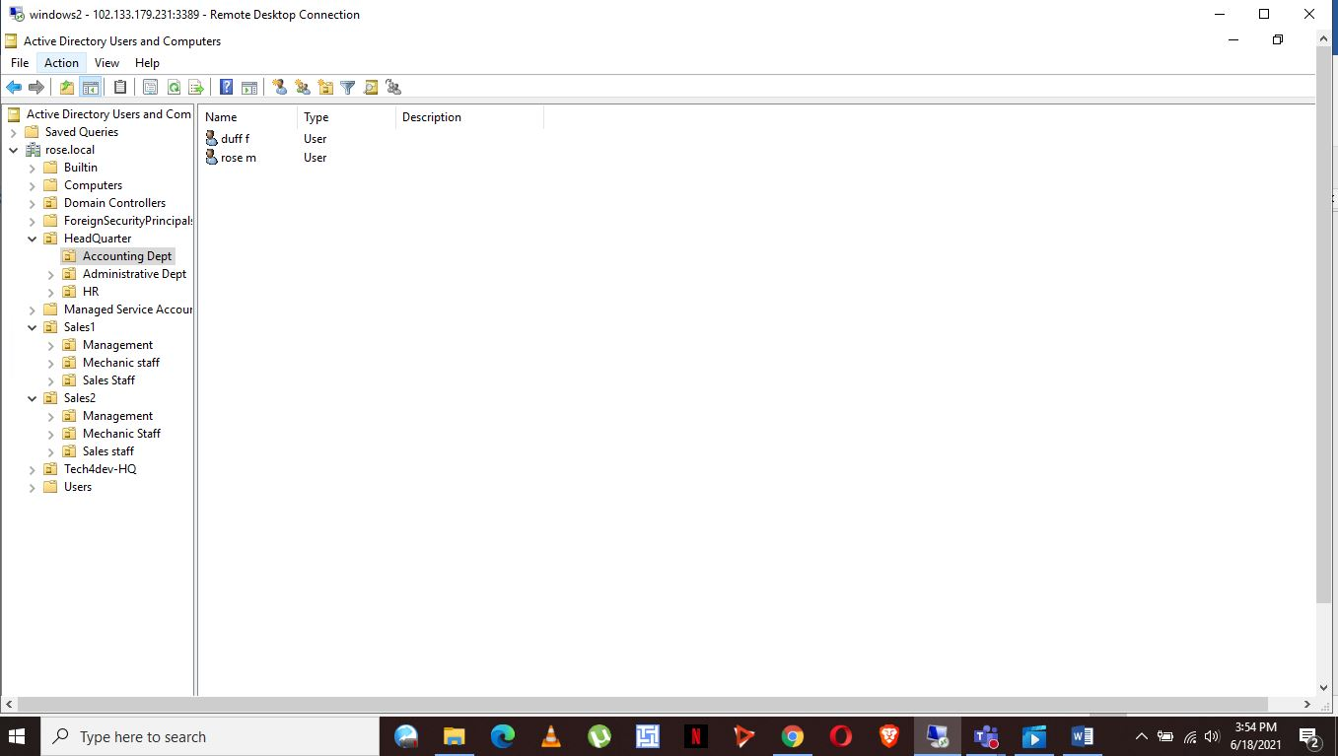

**QUESTION 4**

**In this, one of the mechanical staff leaves for a month. The users account has to be deactivated until the user can join back. I created a policy that will enable the users account stay locked until the administrator can unlock it. I navigated to the group policy on the tools tab, then to the mechanical staff group. The only user to be locked was lucy in my case so ensured the scope did not affect other users in the mechanical staff group. Edit the newly created policy; on windows, settings then security setting navigate to Account policies then to account lockout policy. In the account, lockout duration properties set the amount of time the account should stay locked**

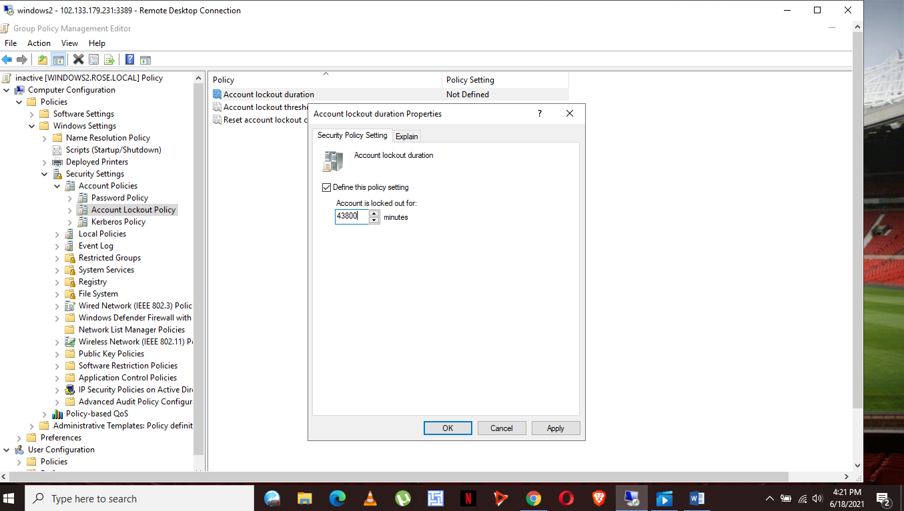

**QUESTION 5**

**First step to adding a policy**

**On the server manager navigate to tools then group policy management. Then click on the account unit and add a new group policy. Name the policy; edit the added policy via the management editor mode. Navigate to policies, windows settings, security setting, and local** **policies security options then navigate through the many undefined policies until interactive logout machine inactivity unit. Apply the necessary logout settings**

